**Statistical Methods - Quiz 7**

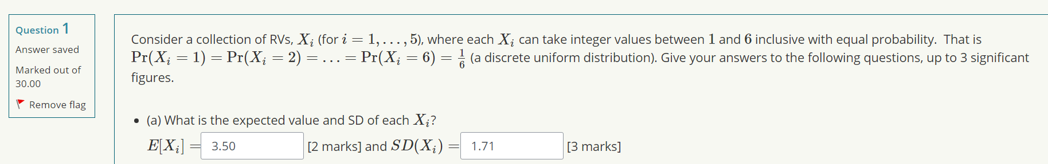**Question 1 (a)**

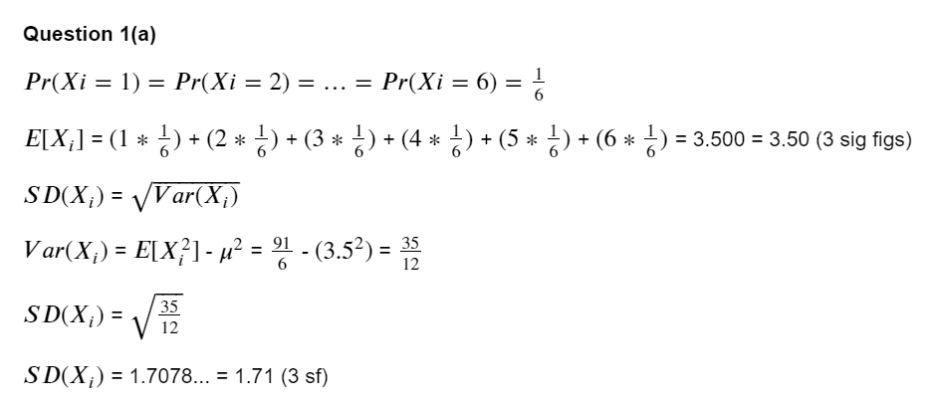E[Xi] and SD(Xi) was calculated as follows:

Assistance was from:

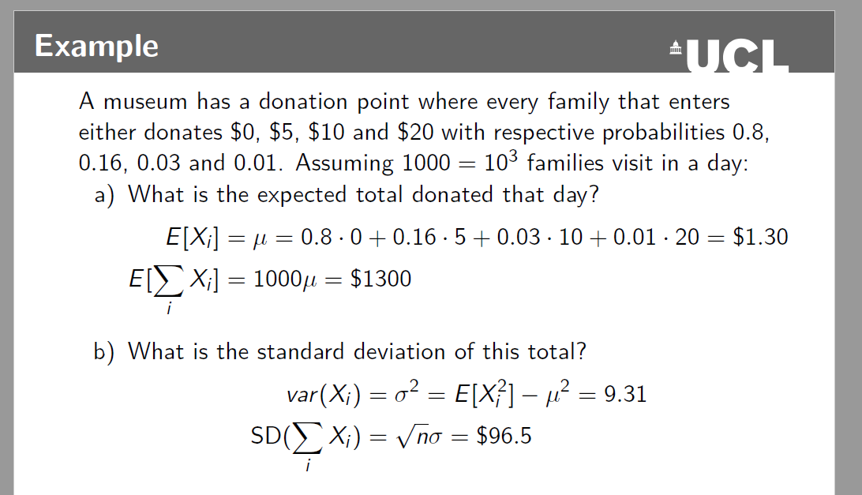

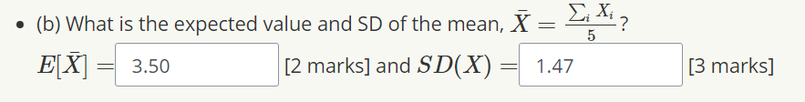**Question 1 (b)**

E[bar X] and SD(bar X) was calculated as follows:

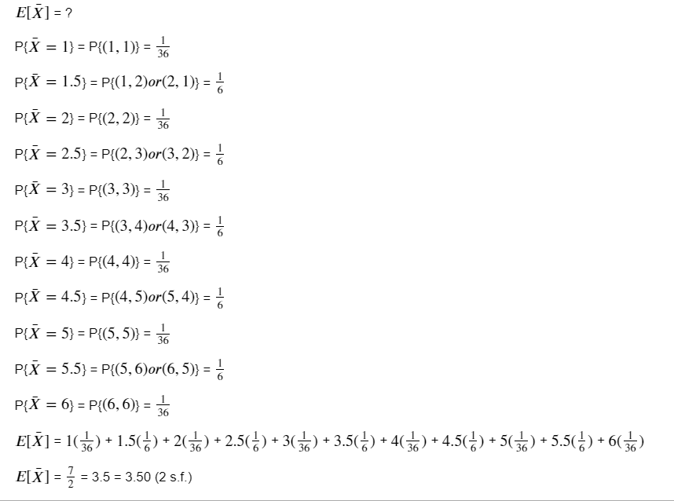

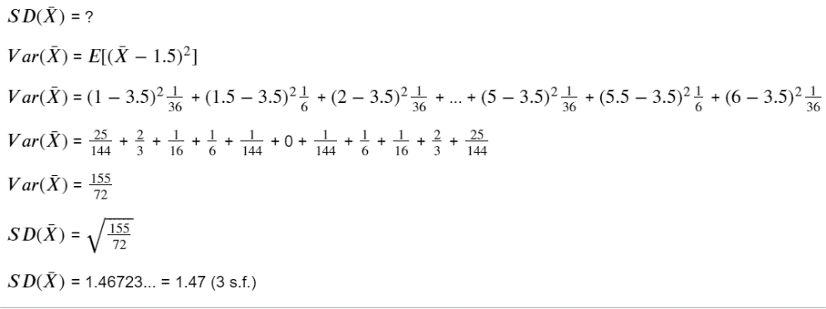

Assistance from (introductory statistics page 301):

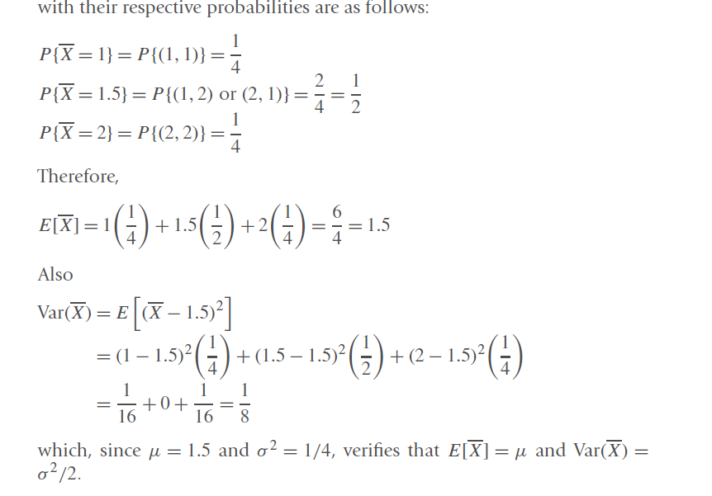

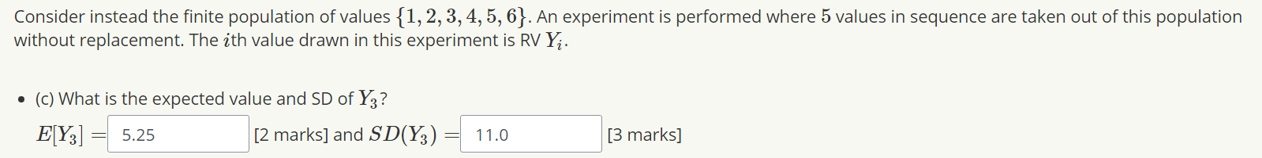**Question 1(c)**

I found that question 1(c) is similar to question 1(a)

6 * 5 * 4 * 3 * 2 = 720 possible sets of 5 numbers from 6 digits

E[Y3] indicates that it is the third value in the sequence (2 numbers have been selected)

Therefore:

4 * 3 * 2 = 24 possible sets of 3 numbers from 4 digits

Not sure what to do from this point on, although I know how to calculate E[X] and SD[X]

I guess the question here is how to calculate E[X] and SD[X] when you don’t know the X values in advanced? I don’t think calculating 24 E[X]’s then averaging them is the right way to go either ☹

Due to the failure of doing **Question 1(c),** I cannot do **Question 1(d)** and **Question 1(e)**

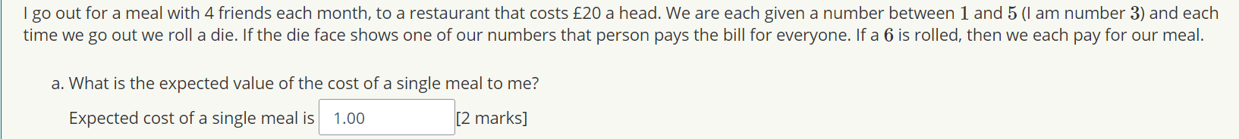**Question 2(a)**

Expected single cost means a 6 has been rolled

The characteristic (k) is 6 being rolled

Therefore Pr(X = 0) for rolls 1,2,3,4,5 (except 6)

Pr(X6 = 1) = k/N = 1/6 (rolling 6)

*p* = 1/6

E[X] = *np*

E[X] = 6 * (1/6)

E[X] = 1.00

**NOTE: I think answer can also be 20.0 because they say value (£20)**

Assistance from:

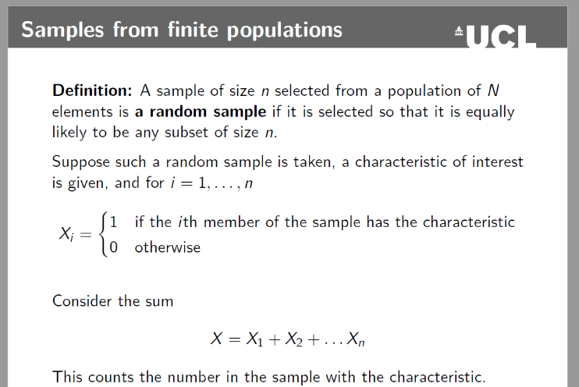

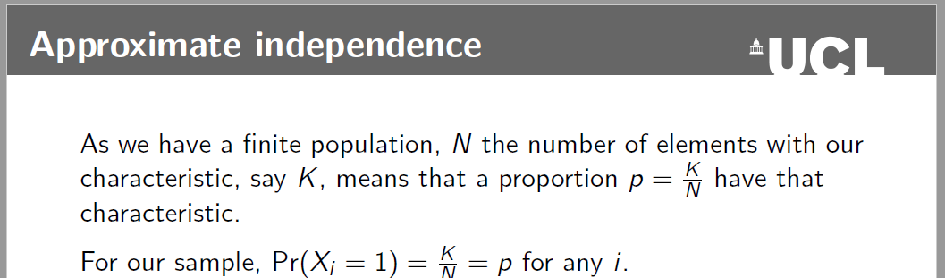

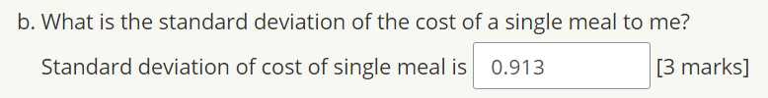**Question 2(b)**

SD[X] calculated as follows:

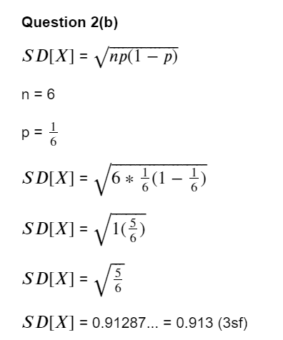

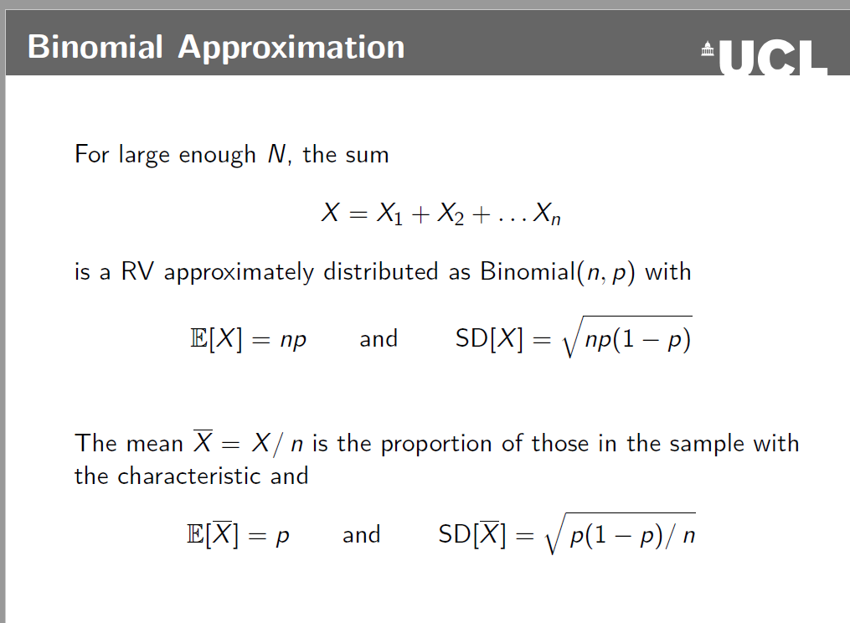Assistance from:

**Question 2(c)**

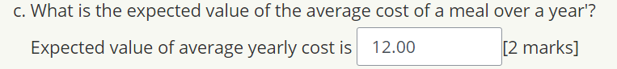

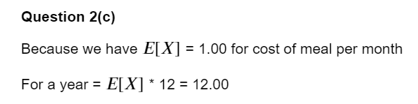My answer:

**NOTE: I think answer can also be 240 because they say value (£20 a month for a year)**

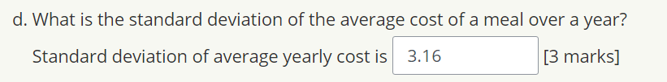**Exercise 2(d)**

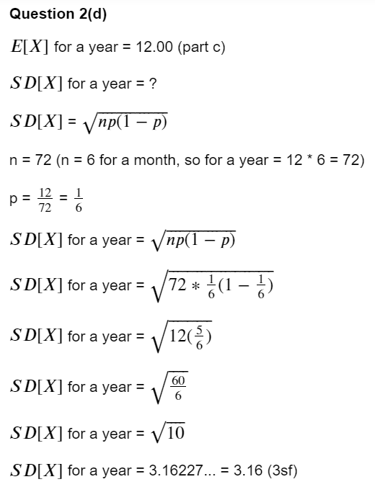My answer:

**Exercise 2(e)**



My answer:

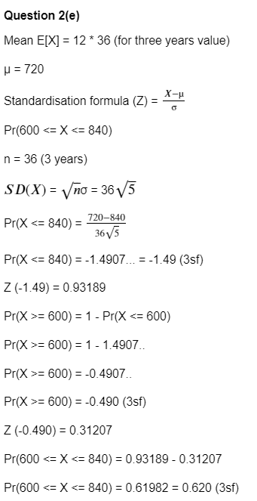

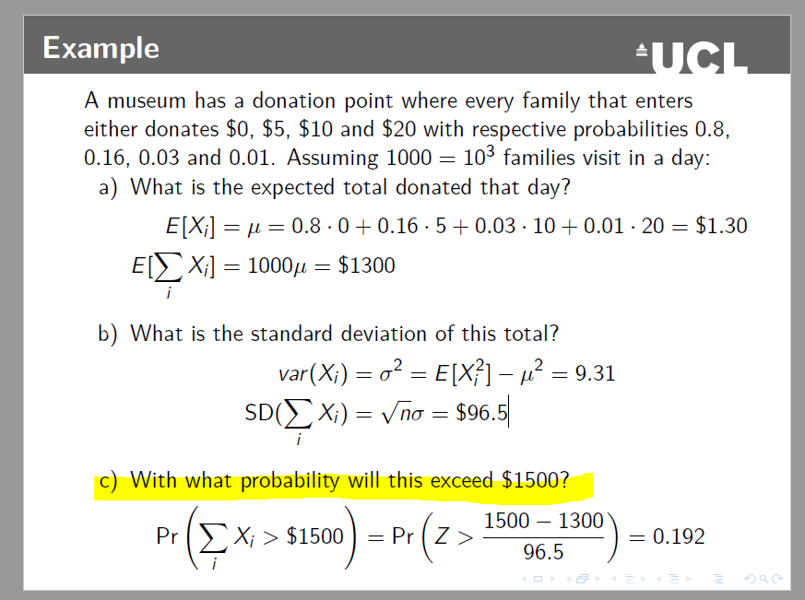Assistance from:

**Exercise 2(f)**

For this question I am completely confused, I suspect it has something to do with lecture 8, but I am not sure.